Summary of the testing procedure for two population means:
      - Hypotheses
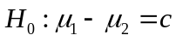 vs. 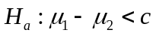 (lower-tail test)
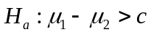 (upper-tail test)
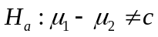 (two-sided test)
      - Significance level
      - Test statistic
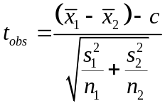
With df = 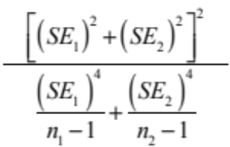 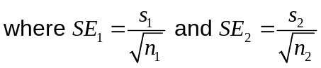

      - P-value = 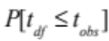 if 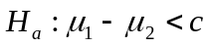

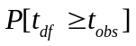 if 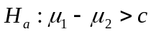

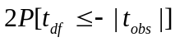 = 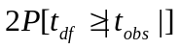 if 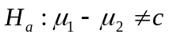

        - Conclusion: Reject  if p-value 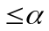, and draw conclusion according to 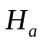，
Otherwise do not reject 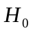, and draw conclusion according to 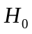

Problem 1. Is there a difference between the life of batteries made by Duracell and Eveready? Let 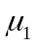 be the mean lifetime (in days) for Duracell batteries, and 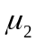 be that of Eveready batteries. Perform a 5% level of test.
 | Duracell | Eveready
n (batteries) | 8 | 10
 | 41 | 45
Sample SDs | 18 | 20
Suggested Solution:
Step 1: Specify the hypotheses
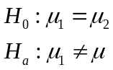
Step 2: significance level =0.05
Step 3: test statistic
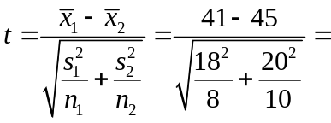-0.45
Note that 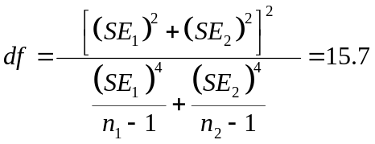 (So we cannot use the normal table)
Step 4:
p-value = 0.694
Step 5: conclusion:
If p-value < , then we reject 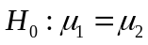and draw conclusion according to
Otherwise do not reject , and draw conclusion according to . Since p-value > the significance level, we don’t reject

Problem 2 The efficacy of a treatment for hypertension (high blood pressure) is to be studied using a small clinical trial. Thirty-eight hypertensive patients were randomly allocated to either Group 0 (placebo control) or Group 1 (treatment) and a three-month follow-up study was carried out. At the end of the study, the difference in blood pressure was measured for patients in each group and recorded. A summary of the results is presented below:
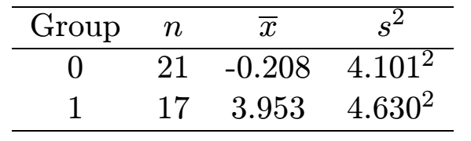
Is there evidence of significant improvement in the treatment group? Use a significance level of = 0.05.
Suggested Solution:
We will assume that the two data sets are two independent random samples from two normal models with the same(unknown) standard deviation ,σ that is
Step 1:
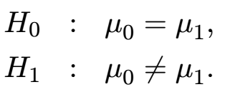
Step 2: significance level =0.05
Step 3: test statistics
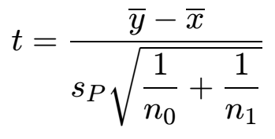
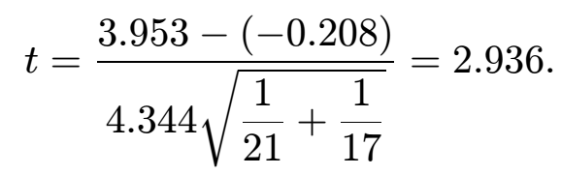
Step 4:
The degrees of freedom is 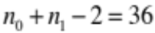 and thus the critical value is 2.028.
Step 5: conclusion:
since t lies in the critical region, we have evidence to reject H0. The
p-value is given by

Problem 3: Twelve cars were equipped with radial tires and driven over a test course. Then the same 12 cars (with the same drivers) were equipped with regular belted tires and driven over the same course. After each run, the cars’ gas economy (in km/l) was measured. Is there evidence that radial tires produce better fuel economy? (Assume normality of data and use =0.05.)
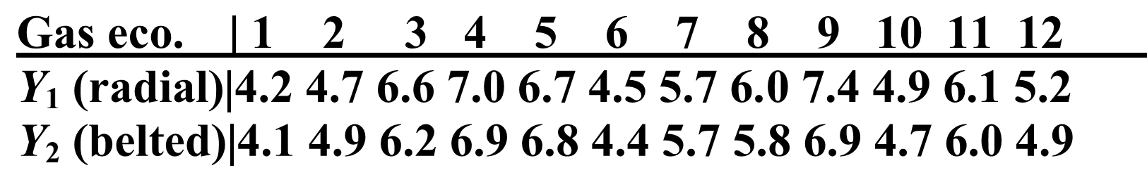
Find a 95% CI for the mean difference in gas economy between radial tires and belted tires.

      - Hypotheses
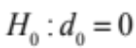
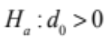
      - Significance level =0.05
      - Test statistic
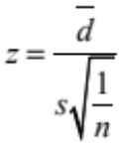, with 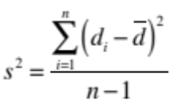
since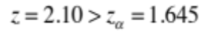 , p-Value is 0.02<0.05, we reject and draw conclusion that there is evidence that radial tires produce better fuel economy.

      - the 95% confidence interval:
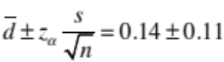
so the 95% confidence interval is (0.03, 0.25).

Problem 4 Many people take Ginkgo supplements advertised to improve memory. Are these over-the-counter supplements effective? In a study, elderly adults were assigned to the treatment group or control group. The 104 participants who were assigned to the treatment group took 40 mg of Ginkgo 3 times a day for 6 weeks. The 115 participants assigned to the control group took a placebo pill 3 times a day for 6 weeks. At the end of 6 weeks, the Wechsler Memory Scale was administered. Higher scores indicate better memory function. Summary values are given in the following table:
 | N |  | s
Ginkgo | 104 | 5.7 | 0.6
Placebo | 115 | 5.5 | 0.5
Based on these results, is there evidence that taking 40mg of Ginkgo 3 times a day is effective in increasing mean performance on the Wechsler Memory Scale?

Step 1: parameters of interest = 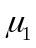, the average memory score using Ginkgo, and 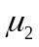, the average memory score using placebo.

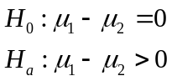
Step 2: significance level is usually taken to be =0.05

Step 3: test statistic =
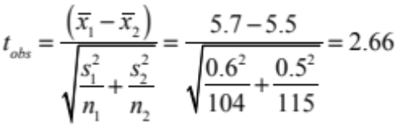

Step 4: 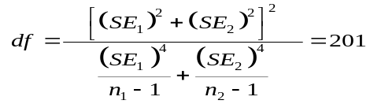 and thus p-value = 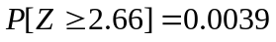
Step 5: Conclusion: Since the p-value < significance level, we reject 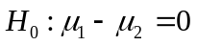 and conclude that Ginkgo does improve the memory score.

Example 5 Assume that Peet’s Coffee is looking at two possible locations for a new shop. To help make a decision they look at the number of pedestrians that go by each of the two locations in one-hour segments. The results of the random sample are shown below:
Location A Location B
Mean number of pedestrians 421 347
Sample standard deviation 122 85
Number of hours sampled 35 50

Assume the two population variances are not known but equal. Complete the steps required to test the null and alternative hypothesis at the 1% level of significance that both sites have the same number of pedestrians and calculate the 95% confidence interval.

Step 1 H₀: µ₁ = µ₂ , H_{a}: µ₁ ≠ µ₂

Step 2 Using an α = .01, reject if the t test statistic is ≥2.576 =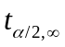 or if the p-Value is ≤ 0.01.

STEP 3 Since our t test statistic 3.30 >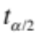=2.576 and since our p-Value is .0014 < α, we reject 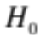 . In addition, our hypothesized difference of 0 is not contained in the 95% confidence interval, but the mean difference of 74 is included in the confidence interval which confirms that we are correct in rejecting the null hypothesis. Thus, the difference in the means is statistically significant.

STEP 4 Given that our p-value is .0014, there is a overwhelming evidence or a highly statistically significant difference between the two sites. Thus, Peet’s should use Location A for their new coffee shop.

Example 6 Assume that an English comprehension test is given to a random sample of 12 students before and after they complete an English course. Their scores are shown below before the course and after the course. Complete an hypothesis test to determine if the course improved the test score.

After | Before
115 | 111
115 | 108
119 | 114
117 | 105
114 | 102
114 | 106
109 | 100
110 | 103
106 | 101
112 | 105
115 | 107
111 | 107

Step 1 H₀: D₀ = 0, H_{a}: D₀ > 0

Step 2 Using an α = .05, reject if the t test statistic is 2.201=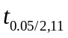01, 11) or if the p-Value is ≤ 0.05.

STEP 3 Since our t test statistic 9.38 > =2.201 and since our p-Value is 6.97E-07 < α = .05, we reject H0. In addition, our hypothesized difference of 0 is not contained in the 95% confidence interval, but the mean difference of 7.333 is included in the 95% confidence interval which confirms that we are correct in rejecting the null hypothesis.

STEP 4 Given that our p-value is 6.97E-07 and we are rejecting H0, there is a statistically significant difference between the after course test scores compared to the before course test scores. Thus, there is overwhelming evidence that the course improves students English test scores.

Example 7 In a market research study conduct by Marilyn Merlot Winery on red wine preference, the following results were found. Of a sample of 500 men, 210 preferred red wine and of a sample of 500 women, 120 preferred red wine. Perform an hypothesis test to determine if the proportion of men preferring red wine is 25% higher than for women.

Step 1 H₀: π_{m} – π_{w} = 0, H_{a}: π_{m} – π_{w} > .25

Step 2 Using an α = .05, reject H0 if the z test statistic is ≥ 1.645 or if the p-Value is ≤ 0.05.

Step 3 Select Hypothesis Tests, Compare Two Proportions, enter the data given the above problem, and click OK. Your dialogue box should look like the one shown below.

STEP 3 Since our z test statistic 6.05 >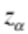 =1.645 and since our p-Value is 7.12E-10 < α = .05, we reject H0. In addition, our hypothesized difference of 0 is not contained in the 95% confidence interval, but the sample mean difference 0.18 is contained within the 95% confidence interval which confirms that we are correct in rejecting the null hypothesis.

STEP 4 Given that we are rejecting H0, there is a statistically significant difference between the proportion of men who prefer red wine compared to women. There is overwhelming evidence that the proportion of men who prefer red wine is greater than 25% compared to the proportion of women.

Example 8 A random sample of 10 hot drinks from Mexin A had a mean volume of 203 ml and a standard deviation of 3 ml. A random sample of 15 hot drinks from Mexin B gave corresponding values of 206ml and 5ml. The amount dispensed by each machine may be assumed to be normally distributed. Test, at the 5%significance level, the hypothesis that there is no difference in the variability of the volume dispensed by the two machines.

Step 1 H₀: 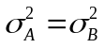 , H_{a}: 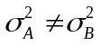

Step 2 Using an α = .05, 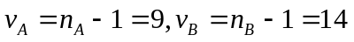and by linear interpolation
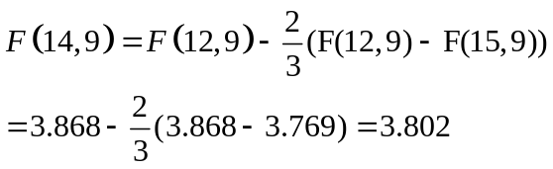

Step 3 Test statics is 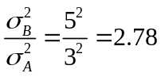

STEP 3 The critical region is 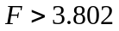

STEP 4 This value does not lie in the critical region. Thus there is no evidence, at the 5% significance, of a difference in the variability of the volume dispensed by the two machines.

Example 9 DST of UIC decides to test the effect of using a statistics software to aid in teaching. The teacher wishes to determine whether using the software will result in an improvement in one's understanding of the topic. The teacher randomly assigns the student into two groups, a control group receiving standard lessons and an experimental group using the software. The students are selected to pairs of equal mathematical ability, with one from each pair assigned at random to the control group and the other to the experimental group. A test is finally conducted to measure their understanding and the results are shown in bellow. Assuming marks to be normally distributed, investigate the claim that the educational computer software produces an improvement in student's understudying of Statistics.

Pair | 1 | 2 | 3 | 4 | 5 | 6 | 7 | 8 | 9 | 10
Control | 72 | 82 | 93 | 65 | 76 | 89 | 81 | 58 | 95 | 91
Experimental | 75 | 79 | 84 | 71 | 82 | 91 | 85 | 68 | 90 | 92

Suggested Solution:

Step 1 H₀: 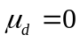, Difference = Experimental- Control
H_{a}: 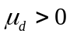(One tailed)

Step 2 Using an α = .05, degree of freedom, 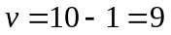

Step 3 Test statics is 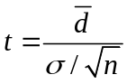

STEP 3 The 10 differences are
d = 3 -3 -9 6 6 2 4 10 -5 1
Hence 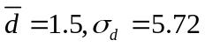 and 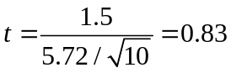 < critical value of 1.833
STEP 4 This value does not lie in the critical region. Thus there is no evidence, at the 5% significance, to suggest that the software produces an improvement in students' understanding of statistics.

Example 10 The Vitamin C (VC), in milligrams per litre, of water in the upper reaches of Pearl River is known to be normally distributed with a standard deviation of 10mg/l. VC readings in the lower reaches of the Pearl River is also known to be normally distributed, but with a standard deviation of 25mg/l. Ten VC readings are made in the upper reaches of the Pearl River and fifteen in the lower reaches with the following results.
Upper reaches | 91,75,91,88,94,63,86,77,71,69
Lower reaches | 86,95,135,121,68,64,113,108,79,62,143,108,121,85,97

Investigate, at the 1% level of significance, the claim that the true mean VC of water in the lower reaches of this river is greater than that in the upper reaches.

Suggested Solution:

Step 1 H₀: 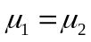 , H_{a}: 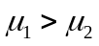
Step 2 Using an α = .01

Step 3 Test statics is 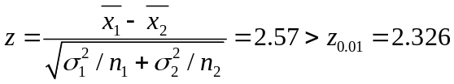

STEP 4 This value lie in the critical region of , so is rejected. Thus there is no evidence, at the 1% significance, to suggest that the true VC of water in the upper reaches of the Pearl River is greater than that in the lower reaches.

